CO1 DESIGN TASK ASSIGNMENT
ENGINEERING DESIGN REPORT
Student detail | Information
Name | K. Shalini
Registration number | 192512270
Course Code and Name | ECA0801– Analog and Digital Communication
Course Outcome | CO1

STAGE 1 INTERPRET THE COMMUNICATION DESIGN REQUIREMENT

1.1 REQUIREMENTS AND DESIGN STATEMENT
Parameter | Given / design value | Engineering implication
Message signal | Voice/audio, f_m(max) = 4 kHz | Baseband message bandwidth B_m = 4 kHz
Available RF band | 540–1600 kHz | Total span = 1060 kHz
Candidate carrier | 1 MHz | Within the stated band; subject to allocation approval
Channel spacing | 20 kHz | Ideal channel count = floor  (1060/20) = 53
AM modulation index | m = 0.7 | Below 1, so no overmodulation for a single-tone AM test
Carrier power | P_c = 10 W | Reference power for AM calculations
Channel | AWGN and practical receiver limitations | Filtering, sensitivity, selectivity and detection matter
Implementation | Low-power educational prototype | Prefer bench testing, low voltage and safe RF containment

1.2 BASIC COMMUNICATION-SYSTEM BLOCK DIAGRAM
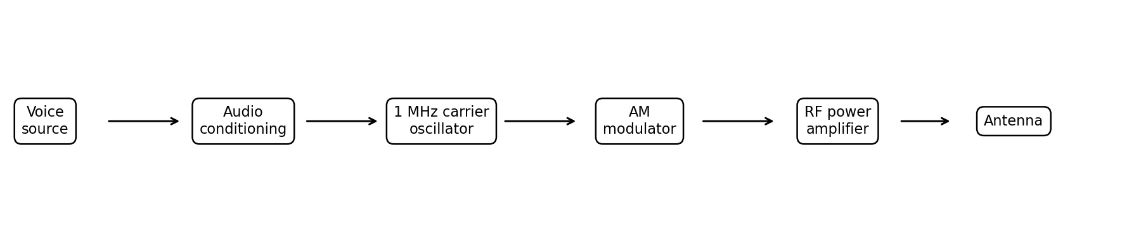At the transmitter, the voice signal is conditioned and used to modulate an RF carrier. The RF power amplifier raises the signal to the required level, and the antenna couples energy into the channel. At the receiver, tuned RF/IF stages select the desired station, the detector recovers the audio envelope, and the audio amplifier drives a speaker.

1.3 WHY MODULATION IS NEEDED
- A 4 kHz baseband signal would require a physically impractical antenna for efficient direct radiation at such a low frequency; a high-frequency carrier enables practical antenna dimensions.
- Modulation moves the message into an assigned RF channel so multiple stations can operate at different carrier frequencies.
- RF filtering and tuned receivers can select one station from several transmissions.
- Direct baseband transmission over a radio link has poor radiation efficiency and does not provide convenient frequency-division channelization.

1.4 MESSAGE AND TRANSMISSION BANDWIDTH
Scheme | Ideal occupied bandwidth for B_m = 4 kHz | Notes
Conventional AM / DSB with carrier | 2B_m = 8 kHz | Upper and lower sidebands plus carrier
DSB-SC | 2B_m = 8 kHz | Carrier suppressed; both sidebands remain
SSB-SC | B_m = 4 kHz | One sideband transmitted
VSB-SC | Approximately B_m + vestige width | One sideband plus a controlled vestige; exact value depends on filter design
For conventional AM centred at 1,000 kHz, the ideal sideband edges are 996 kHz and 1,004 kHz. With 20 kHz carrier spacing, the nearest adjacent carrier is 980 or 1,020 kHz, leaving a 12 kHz gap between the nominal 8 kHz occupied bands (6 kHz from each occupied edge to the midpoint boundary). Practical filters are not brick-wall filters, so this margin must accommodate filter roll-off, frequency error and unwanted emissions.

1.5 IDEALIZED RF CHANNEL COUNT
Available span = 1600 − 540 = 1060 kHz. Idealized channel slots = 1060/20 = 53. This is a mathematical planning estimate only; actual channel centres at band edges and regulatory allocations may reduce the usable count.

1.6 AM POWER CALCULATION
For a single-tone conventional AM signal, with carrier power P_c and modulation index m:
Total sideband power: P_SB,total = P_c m² / 2
Power in each sideband: P_USB = P_LSB = P_c m² / 4
Total transmitted power: P_T = P_c(1 + m²/2)
Given P_c = 10 W and m = 0.7, m² = 0.49.
Quantity | Calculation | Result
Carrier power | P_c | 10.00 W
Total sideband power | 10 × 0.49 / 2 | 2.45 W
Upper sideband power | 10 × 0.49 / 4 | 1.225 W
Lower sideband power | 10 × 0.49 / 4 | 1.225 W
Total AM power | 10 × (1 + 0.49/2) | 12.45 W
Power efficiency | 2.45 / 12.45 × 100% | 19.68%

The 10 W carrier conveys no message by itself; it supports simple envelope detection. For this operating point, about 80.32% of total transmitted power is in the carrier and about 19.68% is in the sidebands.

1.7 RECEIVER PERFORMANCE REQUIREMENTS
- Sensitivity: the minimum input level that still gives an acceptable recovered audio signal and signal-to-noise ratio.
- Selectivity: the ability to accept the desired channel while rejecting adjacent channels.
- Fidelity: how accurately the recovered audio follows the original 0–4 kHz message.
- Stability: carrier/local-oscillator drift must be small enough to keep the signal in the IF filter and avoid tuning errors.
- Image rejection: the RF front end should suppress the image frequency before the mixer.
- IF considerations: a fixed IF simplifies high-gain amplification and narrow, repeatable channel filtering.

1.8 PRACTICAL CONSTRAINTS
- Use low-power bench hardware, proper grounding and decoupling, and a dummy load or shielded setup where appropriate.
- Avoid connecting a 10 W RF stage to an antenna unless the frequency, power and operation are authorized.
- Use a stable oscillator, adequate audio low-pass filtering, and a band-pass IF filter.
- The stated 10 W carrier is a calculation reference; the prototype can be scaled down while preserving modulation index and spectral behaviour.

COMMUNICATION DESIGN REQUIREMENT STATEMENT
The link shall carry voice content up to 4 kHz in an RF channel within 540–1600 kHz. The baseline design uses a nominal 1 MHz carrier, 20 kHz channel spacing, conventional AM at m = 0.7 and a 10 W reference carrier for theoretical power analysis. It shall occupy approximately 8 kHz under ideal AM assumptions, recover audio with an envelope detector, and use receiver filtering to limit adjacent-channel interference and noise. A superheterodyne receiver with a nominal 455 kHz IF is selected for fixed-frequency selectivity. The educational implementation shall be low-power and must not assume the candidate carrier is legally available without regulatory confirmation
STAGE 2 – INVESTIGATE AND SELECT THE MODULATION SCHEME

2.1 TIME-DOMAIN AND FREQUENCY-DOMAIN EXPRESSIONS
Let m(t) be the message, c(t) = A_c cos(2πf_c t) be the carrier, and for a single-tone
Example: let m(t) = A_m cos(2πf_m t). Define modulation index μ = A_m/A_c for the conventional AM expression.
Conventional AM: s_AM(t) = A_c[1 + μ cos(2πf_m t)] cos(2πf_c t). Expanding gives a carrier at f_c and sidebands at f_c ± f_m. For a general message, s_AM(t) = A_c[1 + k_a m(t)]cos(2πf_c t), with the scaling selected to prevent overmodulation.
DSB-SC: s_DSB(t) = A_c k_a m(t) cos(2πf_c t). The carrier term is suppressed; both sidebands carry the message. Coherent detection is normally required.
SSB-SC: one sideband is retained and the other sideband and carrier are suppressed. It can be expressed using the Hilbert transform m_hat(t): s_USB(t) = A_c k_a[m(t)cos(2πf_c t) − m_hat(t)sin(2πf_c t); the sign convention for USB/LSB depends on the Hilbert-transform convention.
VSB-SC: a vestigial-sideband filter transmits one full sideband and a controlled portion (vestige) of the other. Its output can be represented in frequency domain as S_VSB(f) = S_DSB(f)H_VSB(f), where H_VSB(f) is shaped to preserve the required baseband response after detection.

2.2 BANDWIDTH, POWER AND COMPLEXITY COMPARISON
Scheme | Bandwidth | Carrier / power | Detection and complexity | Typical application
AM | 8 kHz | Carrier transmitted; lower power efficiency | Simple envelope detector; low complexity | Analog broadcast voice
DSB-SC | 8 kHz | Carrier suppressed; power only in sidebands | Coherent detector and carrier recovery; moderate/high complexity | Carrier-efficient links
SSB-SC | 4 kHz | Carrier and one sideband suppressed; best bandwidth efficiency of these choices | Accurate filtering or phasing plus coherent detection; higher complexity | Narrowband voice
VSB-SC | One sideband plus vestige | Carrier may be reduced/suppressed depending on implementation; efficient spectral compromise | Carefully shaped filter and suitable detector/equalization | Analog television video

2.3 QUANTIFYING POWER ADVANTAGE RELATIVE TO AM
Using the AM case as a reference, its total sideband power is 2.45 W. If the same sideband amplitudes are used for comparison, DSB-SC removes the 10 W carrier and transmits approximately the 2.45 W sideband power, a 10 W carrier-power saving (80.32% of the AM total power is eliminated relative to the 12.45 W AM total). An SSB-SC signal retains only one of the two equal AM sidebands, or 1.225 W for this single-tone reference, while halving the ideal occupied bandwidth from 8 kHz to 4 kHz. This comparison assumes identical sideband reference amplitudes; practical systems may choose different output levels and link budgets.

2.4 WHY VSB IS USED FOR ANALOG TELEVISION
A full double-sideband television video signal would consume a large bandwidth. A single-sideband system can be difficult to realize with ideal filtering when the video spectrum includes components close to the carrier. VSB transmits one sideband nearly completely and only a small vestige of the other. This reduces bandwidth while allowing a practical filter transition near the carrier. The vestigial response must be designed so that the combined transmitter and receiver response gives acceptable amplitude fidelity. VSB is therefore a television-oriented solution, not the simplest choice for this 4 kHz voice link.

2.5 GENERATION AND DETECTION
- AM generation: vary carrier amplitude with the conditioned audio; envelope detection recovers the message when the envelope does not cross zero.
- DSB-SC generation: balanced modulator or product modulator; coherent/product detector with a locally regenerated carrier.
- SSB-SC generation: filter method or phasing/Hilbert-transform method; coherent detection and adequate frequency stability.
- VSB-SC generation: DSB generation followed by a vestigial-sideband filter; receiver filtering/equalization and synchronous or suitable vestigial-sideband detection.

DESIGN DECISION 1
I recommend conventional AM for the baseline educational community-voice prototype because the assignment emphasizes a practical receiver and low implementation complexity. Its 8 kHz ideal bandwidth fits within 20 kHz spacing, and an envelope detector avoids the carrier-recovery circuitry needed for DSB-SC/SSB-SC. The decision accepts lower power efficiency: only 19.68% of the calculated 12.45 W total AM power is in the sidebands. If battery life or transmitter power were the primary constraint, SSB-SC would be preferable because it halves the ideal bandwidth and avoids transmitting the carrier, but it requires a more complex coherent receiver.

STAGE 3 – RF CHANNEL ALLOCATION AND TRANSMITTER DESIGN

3.1 REPRESENTATIVE CHANNEL PLAN
Channel | Carrier centre (kHz) | AM lower edge (kHz) | AM upper edge (kHz) | Adjacent spacing
CH-1 | 960 | 956 | 964 | 20 kHz
CH-2 | 980 | 976 | 984 | 20 kHz
CH-3 (selected) | 1000 | 996 | 1004 | 20 kHz
CH-4 | 1020 | 1016 | 1024 | 20 kHz
CH-5 | 1040 | 1036 | 1044 | 20 kHz

The plan uses five representative carriers separated by 20 kHz. For a 4 kHz maximum message frequency, each ideal AM signal occupies centre ±4 kHz. Nominal adjacent occupied bands are separated by 12 kHz. The 1 MHz station is the selected illustrative channel; actual assignments must be checked against the relevant regulator and local station plan.

3.2 CARRIER AND SIDEBAND LOCATIONS
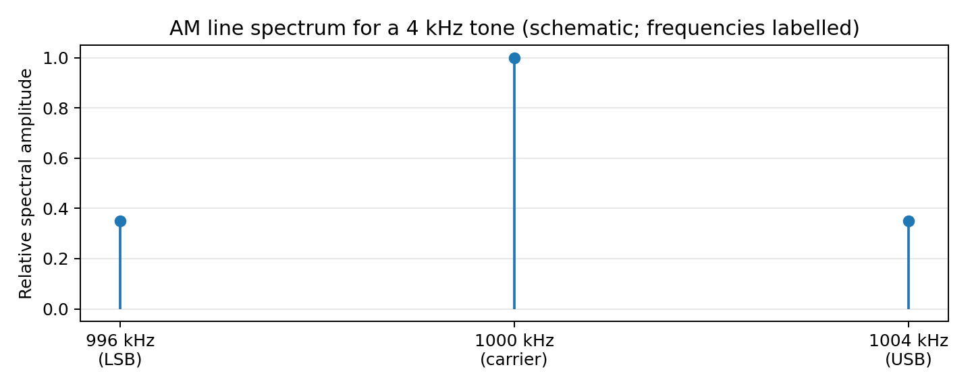
For the 1 MHz carrier and maximum 4 kHz message frequency, the sideband limits are 996 kHz and 1004 kHz. A real voice signal has a continuous spectrum over its message band rather than only three spectral lines; the plotted line spectrum is a single-tone illustration.

3.3 TRANSMITTER ARCHITECTURE
The audio-conditioning stage limits the input to the intended 0–4 kHz band and sets the level. A stable oscillator generates the 1 MHz carrier. The AM modulator sets the desired modulation depth, and a linear RF amplifier raises the output power while minimizing distortion and unwanted spectral regrowth. An output band-pass filter suppresses harmonics before the antenna or dummy load.

3.4 GENERATION/DETECTION BLOCKS FOR THE FOUR SCHEMES
Scheme | Generation chain | Receiver/detection chain
AM | Audio conditioning → carrier oscillator → AM modulator → RF amplifier → band-pass filter | RF/IF selection → envelope detector → audio amplifier
DSB-SC | Audio conditioning + carrier oscillator → balanced/product modulator → RF filter/amplifier | RF/IF selection → carrier recovery/PLL → product detector → audio filter
SSB-SC | Audio conditioning → balanced modulator → sideband filter (or phasing method) → RF amplifier | RF/IF selection → BFO/product detector → audio filter
VSB-SC | Video/message source → modulator → vestigial-sideband filter → RF stage | VSB channel filter → detector/synchronous detector → equalization as required

3.5 GUARD BANDS AND OVERLAP
A 20 kHz centre-to-centre spacing with 8 kHz ideal AM occupancy leaves 12 kHz between nominal channel edges. The practical guard margin is not automatically 12 kHz in a regulatory sense: transmitter frequency error, modulation sidebands, filter roll-off, adjacent-channel emission limits and receiver bandwidth all matter. The channel plan should be verified by measuring the emitted spectrum and checking adjacent-channel rejection.

DESIGN DECISION 2
Use the illustrative 20 kHz-spaced plan and a stable 1 MHz AM transmitter with audio pre-filtering, a controlled modulator, a linear low-power RF stage and output filtering. This provides an uncomplicated demonstrator and ample ideal spectral separation for a 4 kHz message. The trade-off is inefficient carrier power use compared with DSB-SC/SSB-SC. Before real over-the-air use, confirm an authorized frequency and power, and revise the channel plan if local allocations or emission masks require it.

STAGE 4 – SELECT THE AM RECEIVER ARCHITECTURE

4.1 TRF RECEIVER
A tuned-radio-frequency (TRF) receiver amplifies and selects the desired RF signal at or near the received carrier frequency, then detects it and amplifies the audio. It can be simple for a narrow tuning range, but multiple RF tuned stages must track together as the station frequency changes. Selectivity and gain can vary with tuning frequency.

4.2 SUPERHETERODYNE RECEIVER
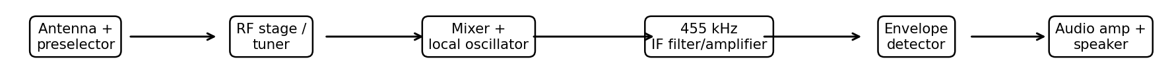
A superheterodyne receiver converts the selected RF signal to a fixed intermediate frequency using a mixer and local oscillator. Fixed IF filters and amplifiers provide stable gain and selectivity across the tuning range. The RF preselector must suppress the image frequency before mixing.

4.3 TRF VERSUS SUPERHETERODYNE
Parameter | TRF | Superheterodyne
Tuning | Several RF tuned circuits may need tracking | RF tuning plus local oscillator; IF remains fixed
Selectivity | Can vary with tuned frequency and circuit Q | Strong, repeatable selectivity from fixed IF filters
Sensitivity | Can be adequate but gain/stability vary across band | High stable gain is practical at fixed IF
Image response | No mixer image in the same sense | Image is a key issue; preselector needed
Complexity | Fewer blocks, potentially simple prototype | More blocks but usually better performance
Best fit here | Useful for a simple demonstration | Recommended stable channel selection and comparison

4.4 IF SELECTION AND IMAGE FREQUENCY
Select a nominal IF of 455 kHz, a common value for AM broadcast receivers. With high-side local-oscillator injection, f_LO = f_RF + f_IF = 1000 + 455 = 1455 kHz. The image is the other RF input that also differs from the LO by 455 kHz: f_image = f_LO + f_IF = 1910 kHz. Equivalently, for high-side injection f_image = f_RF + 2f_IF = 1000 + 910 = 1910 kHz. This image is outside the stated 540–1600 kHz tuning band, which helps, but the front-end preselector should still reject it. With low-side injection, the image would be f_RF − 2f_IF = 90 kHz, also outside the band but below the desired RF. High-side injection is used in the selected calculation.
Quantity | Calculation | Value
Desired RF | Given | 1000 kHz
IF | Selected | 455 kHz
Local oscillator (high-side) | 1000 + 455 | 1455 kHz
Image frequency (high-side) | 1000 + 2(455) | 1910 kHz
Image separation from desired RF | 2 × 455 | 910 kHz

A higher IF generally increases image separation, easing RF image rejection, but can make narrow channel filtering harder. A lower IF helps narrow filtering but places the image closer to the desired station. The 455 kHz value is a practical compromise for a conventional AM receiver.

4.5 DETECTION SUITABILITY
- AM: an envelope detector (diode, RC load) is suitable if the modulation envelope is not overmodulated and the RC time constant follows the audio envelope while filtering the RF carrier.
- DSB-SC: a coherent product detector multiplies the signal by a synchronized carrier; frequency/phase error causes distortion or amplitude loss.
- SSB-SC: a product detector or beat-frequency oscillator reconstructs the missing carrier reference; oscillator stability is important for natural-sounding voice.
- VSB-TV: a shaped VSB filter and compatible detector/equalization are needed to maintain the intended video response.

4.6 RECEIVER PARAMETER ANALYSIS
Parameter | Design implication / verification
Sensitivity | Measure the smallest input level that meets a stated audio quality/SNR target; the assignment gives no numeric sensitivity threshold, so it must be specified during lab verification.
Selectivity | Use an IF passband matched to the 8 kHz AM channel and verify adjacent-channel rejection; actual filter transition bands must be measured.
Fidelity | Check recovered audio across 0–4 kHz for amplitude response and distortion.
Image rejection | Use RF preselection and verify response near the calculated 1910 kHz image for high-side injection.
IF stability | Use a stable LO and IF chain; check drift against the IF filter bandwidth.
Detection | Use envelope detection for AM; coherent detection for suppressed-carrier schemes.

DESIGN DECISION 3
I recommend a superheterodyne receiver with 455 kHz IF because fixed IF filtering offers more consistent selectivity and gain than a TRF design as the receiver is tuned. At a 1 MHz RF input, the high-side LO is 1.455 MHz and the image is 1.910 MHz, separated from the desired station by 910 kHz. An RF preselector is still required. The architecture is more complex than TRF, but it is a stronger engineering choice for a receiver intended to reject adjacent stations and recover voice reliably.

STAGE 5 – DEVELOP, VERIFY AND COMPARE THE COMPLETE SYSTEM

5.1 END-TO-END BLOCK DIAGRAM
Voice source → 0–4 kHz audio conditioning → AM modulator driven by 1 MHz oscillator → RF power amplifier → output filter → approved load/channel → receiver antenna/preselector → RF/mixer/LO → 455 kHz IF filter and amplifier → envelope detector → audio amplifier → speaker.

5.2 AM WAVEFORM AND SPECTRUM
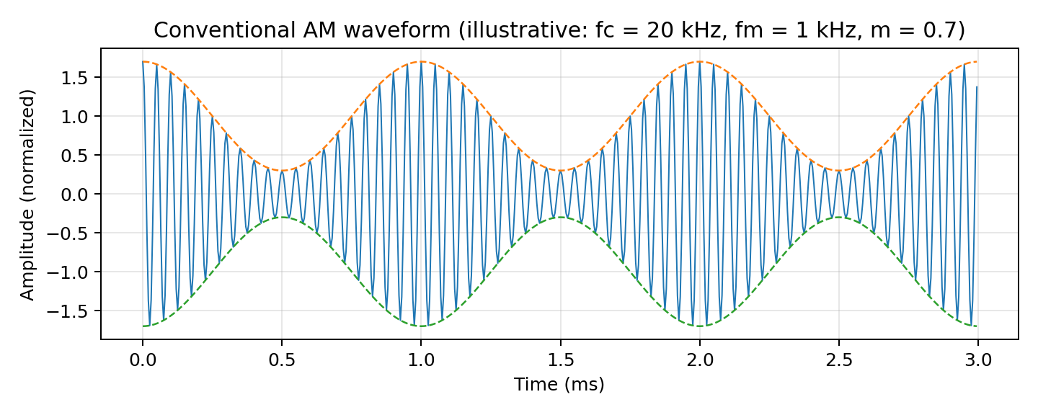
The illustrated waveform uses a 1 kHz tone and a 20 kHz illustrative carrier so several cycles and the envelope are visible in the plot. This is a normalized illustration of the AM equation, not a claim that the hardware was simulated or measured at 1 MHz. The envelope follows the message because m = 0.7 is less than 1.
The frequency plot labels the 1 MHz carrier and the sideband positions for a 4 kHz tone. The ideal bandwidth is the difference between 1004 kHz and 996 kHz, equal to 8 kHz.

5.3 VERIFICATION CALCULATIONS
Verification item | Expected result | Status / interpretation
Message bandwidth | 0–4 kHz; B_m = 4 kHz | Meets brief
AM occupied bandwidth | 8 kHz ideal | Fits within 20 kHz spacing under ideal assumptions
Carrier frequency | 1000 kHz | Candidate only; regulatory check required
Modulation index | 0.7 | Below 1; no overmodulation in ideal single-tone case
Carrier power | 10 W reference | Given design input
Total sideband power | 2.45 W | Calculated
Total AM power | 12.45 W | Calculated
Power efficiency | 19.68% | Carrier-heavy conventional AM
IF | 455 kHz | Selected design value
High-side LO | 1455 kHz | Calculated
Image frequency | 1910 kHz | Calculated; RF preselection needed
Channel plan | 5 centres spaced 20 kHz apart | Illustrative; verify local allocation and spectral mask

5.4 NOISE EFFECTS
Additive white Gaussian noise (AWGN) adds random amplitude and phase variations to the received signal. In conventional AM, noise in the detected envelope can appear as audible hiss or distortion, particularly when the received carrier-to-noise ratio is low. A narrow, well-designed IF filter reduces out-of-channel noise but must be wide enough to pass the 8 kHz AM signal without excessive audio distortion. The envelope detector is simple, but it does not provide the noise performance of every coherent or FM alternative. A stronger received signal, good front-end filtering, correct detector time constant and adequate audio filtering improve the result.

5.5 SELECTED SCHEME VERSUS REJECTED ALTERNATIVE
Criterion | Selected: AM | Alternative: SSB-SC
Ideal bandwidth | 8 kHz | 4 kHz
Carrier power | 10 W reference transmitted | Carrier suppressed
Power reference | 12.45 W total for m = 0.7 | 1.225 W for one AM sideband reference, under stated comparison assumption
Receiver | Envelope detector | Coherent/product detector
Complexity | Low | Higher: sideband generation and carrier recovery
Decision for this assignment | Best simple educational voice demonstrator | Better spectrum/power efficiency if complexity is acceptable

5.6 LOW-COST LABORATORY IMPLEMENTATION
- Build or simulate the audio source, oscillator and modulator at low signal levels first.
- Use MATLAB, Python, GNU Radio or circuit simulation to compare ideal waveforms and spectra before hardware testing.
- For a hardware prototype, use a low-power RF module or signal generator, a suitable dummy load and a spectrum analyzer/SDR where available.
- Record the measured carrier, sideband edges, modulation index, output level and recovered audio response; compare these values with the theoretical table.
- Do not report simulated or measured values unless the relevant tool or instrument was actually run. The figures in this report are analytical illustrations.

STAGE 6 – CRITICAL EVALUATION AND DEPLOYMENT DECISION

6.1 AM, DSB-SC, SSB-SC AND VSB-SC COMPARISON
Criterion | AM | DSB-SC | SSB-SC | VSB-SC
Ideal bandwidth for 4 kHz message | 8 kHz | 8 kHz | 4 kHz | One sideband + vestige
Carrier transmitted | Yes | No | No | Implementation-dependent
Power efficiency | Low; 19.68% for given case | Higher than AM for same sideband reference | High | High spectral compromise
Detection | Envelope | Coherent | Coherent | VSB-compatible detector/equalization
Complexity | Low | Medium/high | High | High/filter-sensitive
Typical use | Analog voice broadcast | Carrier-efficient links | Narrowband voice | Analog television

6.2 SPECIFICATION COMPLIANCE AND UNRESOLVED CHECKS
Requirement | Assessment | Evidence / remaining check
Carry voice up to 4 kHz | Compliant in ideal design | Audio and IF passband must be verified in hardware
Operate within 540–1600 kHz | Candidate fits numerically | 1 MHz is not confirmed as available; check regulatory allocation
20 kHz channel spacing | Ideal plan meets spacing | Measure occupied spectrum, filter roll-off and unwanted emissions
AM index 0.7 | Compliant by design | Measure envelope or use modulator calibration
10 W carrier reference | Power calculation completed | Prototype should be scaled safely; actual RF output must be measured
Receiver performance | Architecture selected | Sensitivity, selectivity, fidelity and image rejection need bench measurement
Noise resilience | Discussed qualitatively | Measure audio SNR at several received signal levels
VSB-TV suitability | Not selected for voice link | VSB is appropriate to TV-type wideband video, not required for this voice channel

6.3 FINAL ENGINEERING DECISION: YES / NO
YES — deploy as a low-power educational prototype, subject to the following conditions. Conventional AM meets the theoretical 8 kHz bandwidth requirement within the 20 kHz channel spacing, and the specified m = 0.7 gives 12.45 W total AM power for a 10 W carrier reference. A 455 kHz superheterodyne IF supports stable filtering; the calculated high-side image at 1.910 MHz is well separated from the 1 MHz desired carrier and can be attenuated by RF preselection. The envelope detector keeps the receiver simple and supports a clear demonstration of modulation and demodulation.
This is not an unconditional recommendation for public over-the-air deployment. The 1 MHz carrier must be confirmed as authorized, and permitted power, emissions, antenna and site conditions must be checked. The assignment’s 10 W carrier power is used for analysis; an educational prototype should operate at a lower, safe level unless authorization and equipment requirements are satisfied. Hardware measurements of spectrum, sensitivity, selectivity, fidelity and recovered-audio SNR remain necessary before claiming a fully verified deployed link.

6.4 REDESIGN IF CONSTRAINTS CHANGE
- If power consumption becomes the main constraint, redesign as SSB-SC to remove the carrier and one sideband; expect 4 kHz ideal bandwidth but higher transmitter and receiver complexity.
- If the receiver cannot reject adjacent stations, improve the IF filter and RF preselector, then re-check audio fidelity and channel occupancy.
- If the assigned carrier is unavailable, choose an authorized carrier while retaining the 20 kHz planning method and re-calculate LO/image frequencies.
- If image rejection is insufficient, revise the RF preselector and consider a different IF architecture; re-evaluate the trade-off between image separation and IF filter design.
- If audio response is distorted, verify the 0–4 kHz audio chain, IF passband and envelope-detector RC time constant.

7. CONCLUSION
The design process has moved from requirements to modulation selection, channel planning, transmitter/receiver architecture, calculations and a deployment decision. Conventional AM is selected because its low complexity and envelope detection are well suited to a low-cost educational voice link. The main quantitative results are 4 kHz message bandwidth, 8 kHz ideal AM bandwidth, 2.45 W total sideband power, 1.225 W per sideband, 12.45 W total AM power and 19.68% sideband power efficiency. A 455 kHz IF with high-side injection gives a 1.455 MHz local oscillator and 1.910 MHz image frequency. The design is suitable for a controlled educational prototype, but legal frequency availability and real receiver/transmitter measurements must be confirmed before any practical deployment.
REFERENCES
[1] S. Haykin, Communication Systems, 5th ed. Hoboken, NJ, USA: Wiley, 2009.
[2] B. P. Lathi and Z. Ding, Modern Digital and Analog Communication Systems, 4th ed. New York, NY, USA: Oxford University Press, 2010.
[3] J. G. Proakis and M. Salehi, Fundamentals of Communication Systems, 2nd ed. Pearson, 2014.
[4] Federal Communications Commission, “AM Broadcast Radio Stations,” FCC consumer and broadcast information. Consult the applicable national regulator for local frequency authorization and rules.
[5] Course handout, “ECA08 – Analog and Digital Communication: CO1 Design Task Assignment,” supplied assignment brief, 7 pp.

